**PROJECT REPORT DOCUMENT**

On

“Predicting Life Expectancy using Machine Learning”



Submitted by

S. Darshni

INDEX

1 **INTRODUCTION**

1.1 Overview

1.2 Purpose

2 **LITERATURE SURVEY**

2.1 Existing problem

2.2 Proposed solution

3 **THEORETICAL ANALYSIS**

3.1 Block diagram

3.2 Hardware / Software designing

4 **EXPERIMENTAL INVESTIGATIONS**

5 **FLOWCHART**

6 **RESULT**

7 **ADVANTAGES & DISADVANTAGES**

8 **APPLICATIONS**

9 **CONCLUSION**

10 **BIBILOGRAPHY**

1: INTRODUCTION

1.1: Overview

Life expectancy is the estimated age to which a person will live. This number depends on various reasons – demographic, socio-economic, hereditary, and so on. Over years of data collection, the Global Health Observatory under WHO (World Health Organization) has created a database of estimated average life expectancy in 193 countries from 2000-2015, including factors such as adult mortality, alcohol consumption, BMI, polio and Hep-B immunization coverage, etc.

The aim of this project is to create a machine learning model, with this database as the starting point, to predict life expectancy for a given country and various factors.

1.2: Purpose:

Machine learning is emerging as a technology that can be used to process data and generate solutions to real-life problems. Applying it to problems in the medical field can minimize the burden on the medical workforce and help to deal with the treatment of hundreds of patients every day.

2: LITERATURE SURVEY

2.1: Existing problem

In an ever-changing world with many changing variables, predicting the life expectancy of any country with existing methods is a difficult task. Being able to do so can be very helpful to doctors by giving them a sort of reference to determine treatment for their patients.

2.2: Proposed solution:

A regression machine learning model which uses historical data to predict average life expectancy in any country, given several values

3: THEORETICAL ANALYSIS

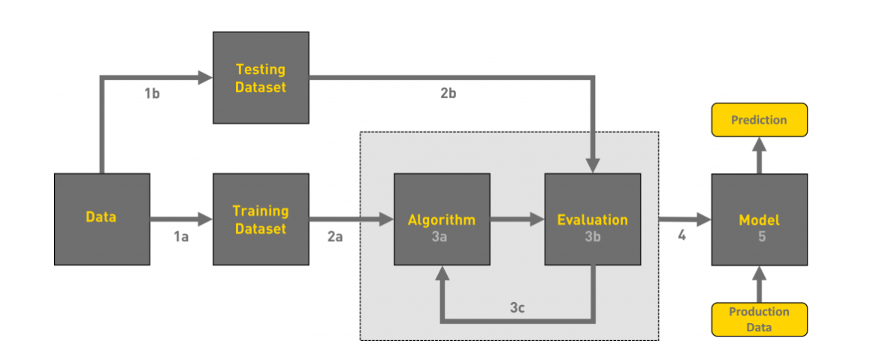3.1: Block diagram

3.2: Hardware/software design

The required software for this project is:

*IBM Watson Studio (for generating the ML model)

*Node-Red (to deploy the ML model and create webpage for life expectancy prediction)

*IBM Cloud (for storing the needed database)

4: EXPERIMENTAL INVESTIGATIONS

1. Choose a Project Idea: As mentioned before, predicting average life expectancy in a country.

2. Conduct Background Research: The required data for creating the prediction model can be obtained from Kaggle. Next, the various types of machine learning models are compared.

3. Compose a Hypothesis: Based on our study and information gathered, we can determine the required type of ML model needed to predict life expectancy.

4. Design your Experiment: The database is collected and stored in IBM Cloud. Next, the required ML model is generated using an Auto-AI experiment in Watson Studio. Finally, the model is integrated in a Node-Red flow.

5. Draw Conclusions: After construction of the model, we can predict the average life expectancy in a given country.

5: FLOWCHART

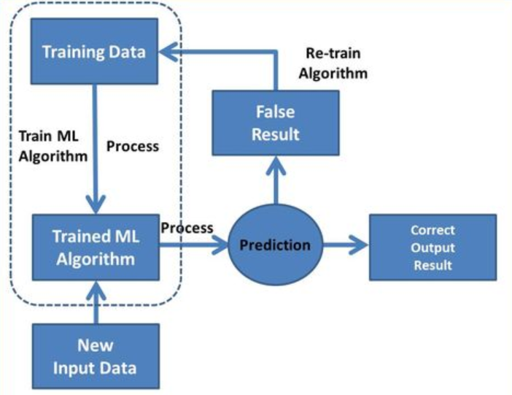

6: RESULT

An effective machine learning model for predicting life expectancy in a country has been created.

7: ADVANTAGES/DISADVANTAGES

Advantages:

*Reduces data processing times

*The model can be updated and modified easily

Disadvantages:

*Wrong data can reduce the accuracy of the model, so it has to be updated manually

8: APPLICATIONS

This process of generating a machine learning model can be applied for any problem statement, given the proper database. This makes the model versatile and usable in just about any field.

9: CONCLUSION

Through this internship project, the process and method of creating a machine learning model has been learned.

10: BIBLIOGRAPHY

<https://www.kaggle.com/kumarajarshi/life-expectancy-who/data>

<https://ourworldindata.org/life-expectancy>

<https://en.wikipedia.org/wiki/Life_expectancy>

<https://bookdown.org/caoying4work/watsonstudio-workshop/jn.html>

<https://developer.ibm.com/tutorials/watson-studio-auto-ai/>